***COMPARISION OF MACHINE LEARNING AND DEEP LEARNING CLASSIFICATION ALGORITHMS***

*Satyanshu Singh(TEAM LEADER) Vidit Dixit*

Department of CS : Computer Engineering Department of CS : Computer Engineering

ABES Engineering College (APJAKTU) ABES Engineering College (APJAKTU)

Ghaziabad, U.P., India Ghaziabad, U.P ,India

[satyanshu.19b151036@abes.ac.in](mailto:satyanshu.19b151036@abes.ac.in) [vidit.19b151030@abes.ac.in](mailto:vidit.19b151030@abes.ac.in)

*Yash Bhardwaj Ms.Poonam Rana* Department of CS : Computer Engineering Department of CS : Computer Engineering

ABES Engineering College (APJAKTU) ABES Engineering College (APJAKTU)

Ghaziabad, U.P., India Ghaziabad, U.P ,India

[yash.19b151066@abes.ac.in](mailto:yash.19b151066@abes.ac.in) [poonam.rana@abes.ac.in](mailto:poonam.rana@abes.ac.in)

***Abstract- Machine learning is the scientific study of algorithms and statistical models that computer systems use to perform a particular task without using evident instructions, relying on patterns and conclusion instead. ML seems to be part of AI. This is because today a huge amount of data is available which lets machines be taught rather than programmed.***

***How machine learning is transforming different field:-***

***ARTIFICIAL INTELLGENCE:-* *Most scientist community says ML grew out from AI. They trying to approach the problem with different symbolic methods. ML is different field and started to flourish in 1990s. Beside some practitioners, say’s that ML and AI are separate*.**

***STATISTICS:- Machine learning and statistics are common fields in terms of methods, but distinct in their principal goal: statistics makes population inferences from a sample, while machine learning works for generalize predictive patterns.* *OPTIMIZATION:-* *ML also has denote ties to optimization. The difference between the two field comes from the purpose of generalization: while optimization algorithms can attenuate the harm on a training set, ML is related with attenuate the harm on unseen samples***

***EDUCATION:-The digital system collect each records and can give accurate classified report as they needed. This doesn’t means no need of teacher because of innovation of these technology though these can’t fulfill various roles as teacher play but can be automated through machine learning.***

***HEALTHCARE:-ML programs can predict health queries based on age, socioeconomic status, and ancestral history which helps restrict sickness. ML algorithm find out cancer more accurately than the best pathologist, freeing doctors for making the treatment decision more accurate and fast* .**

***Deep learning is known as deep structured learning. It is a part of ML methods based on artificial neural networks with representation learning*.**

***How Deep learning is transforming different field:-***

***MEDICAL IMAGE ANALYSIS:- Deep learning has given an tremendous results in medical application such as image enhancement , organ segmentation, lesion detection and cancer cell classification .***

***MILITARY:-* *The US Department of Defense applied deep learning used to exercising robots in new tasks through scanning.***

***FINANCIAL FRAUD DETECTION:-Deep anti-money laundering detection system can find out and diagnose kinship and affinity between data and learn to detect similarities or classify and predict particular events.***

***IMAGE RESTORATION:-Deep learning application include method such as "Shrinkage Fields for Effective Image Restoration" which exercise on an image dataset, and Deep Image Prior, which exercise on the image that needs restoration*.**

***BIOINFORMATICS:-Gene ontology annotations and gene-function kinship is predicted by auto-encoder ANN in bioinformatics .Sleep quality and health complication are bodment by deep learning on the basis of recorded data***

***CUSTOMER RELATIONSHIP MANAGEMENT:-RFM variables can be defined as approximate the value of possible direct marketing actions by use of deep reinforcement learning .***

***NATURAL LANGUAGE PROCESSING:-Since in early 2000s Neural networks have been used for implementing language models .LSTM used to reform machine translation and language modeling.***

# Introduction

**“Machine Learning** is study of computers to seek out and behave like humans by providing them data and knowledge from observations and real-world interactions or communication and upgrade their learning over time in self-governing style.”

Machine learning (ML) is the analysis of computer algorithms that improve by itself through expertise. It is a part of Artificial Intelligence that helps computer systems to automatically learn and improve itself from experience without being exactly programmed by any human. It makes computers learn from provided data so that they perform some specific tasks. The process of learning starts with observations of data by direct experience or instruction, so that it can create a pattern and make better in future depending on examples or data which we provide..The main aim is to allow the computers learn by them self without any human assistance.

**TYPES OF MACHINE LEARNING ALGORITHMS-**

Machine learning algorithms are classified into following categories.

**Supervised ML algorithms-** They can apply , using examples to predict future result what has been learned previously to new information**.**

**Unsupervised ML algorithms-** They are used when data is neither labeled nor tabulated.

**Semi-supervised ML algorithms-** The computer systems which use these type of ML algorithms are able to upgrade learning skills and accuracy. They have both labeled and unlabeled data for training so they lie in between supervised and unsupervised learning algorithms.

**Reinforcement ML algorithms-** This is a learning method that communicates with its environment by generating actions and finds mistakes or rewards. Most common characteristic of reinforcement search is trial and error search.

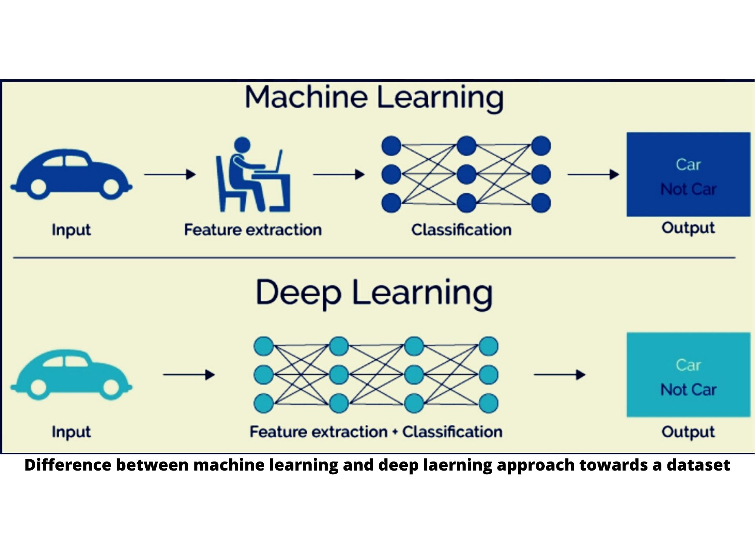

**“Deep learning** could also be a kind of machine learning that gains major power and adaptableness by learning to represent the earth as nested hierarchy of concepts, with each concept defined in regard to simpler concepts, and more abstract representations computed in terms of less abstract ones.”

Deep learning is a part of machine learning in artificial intelligence and is also known as deep neural learning or deep neural network because it has networks capable of learning unsupervised from information that is unstructured or unlabeled.

Deep learning is a machine learning process in which a computer system learns to perform classification tasks directly from images, text, or sound. It teaches computers system to perform required tasks from those things which come naturally from humans.

**COMPARISION OF MACHINE LEARNING AND DEEP LEARNING-**

**Data dependencies-** The most important difference between deep learning and machine learning depends upon their performance when different scale of data are used. Deep Learning algorithms does not perform well when the amount of data is less as deep learning algorithms require a large amount of data to understand.

**Hardware dependencies-** Deep learning algorithms require high-end machines whereas machine learning algorithms can work on low-end machines.

**Feature engineering-**Feature engineering could also be a process of putting domain knowledge into the creation of feature extractors to reduce the complexity of the data and make patterns more visible to learning algorithms to work. This process is difficult and expensive in terms of your time and expertise. In Machine learning, most of the applied features got to be identified by an expert then hand-coded as per the domain and data type.

**Problem Solving approach-** Problem solving technique in machine learning algorithm recommends to break the problem down into different parts and solve them separately and then combine the result where as deep learning recommends to solve the problem end-to-end.

**Execution time-**Generally, a deep learning algorithm trains in longer time. This is because there are numerous parameters during a deep learning algorithm that training them takes longer than usual.

|  |  |
| --- | --- |
| **MACHINE LEARNING** | **DEEP LEARNING** |
| **1.DATA DEPENDENCIES**-Machine Learning algorithms perform well when data is small. | **1.DATA DEPENDENCIES**-Deep Learning algorithms perform do not well when data is small as they need large amount of data to understand it perfectly. |
| **2.HARDWARE DEPENDENCIES-** Machine Learning algorithms perform well on low end machines. | **2.HARDWARE DEPENDENCIES-** Deep Learning algorithms depend heavily on high end machines. |
| **3.PROBLEM SOLVING APPROACH**-In machine learning algorithms it is recommended to break the problems into different parts, solve them individually and combine the result. | **3.PROBLEM SOLVING APPROACH**- Deep learning algorithms solve the problem end to end. |
| **4.Execution Time-** Machine Learning algorithms take shorter time to execute. | **4.Execution Time-** Deep Learning algorithms generally take longer time to execute. |

Literature review

**A data set can be converted into model using machine learning and deep learning.**

Machine learning and deep learning not only widely embraced but also widely misunderstood. In this literarture review, we’d like to explain both machine learning and deep learning algorithms, and explain in brief how to a set of data gets converted into model.

**Different type of algorithm is used to discuss different type of problems.**

**Different types of machine learning algorithm are:-**

1. **Principal Component Analysis (PCA) –**

PCA is a statistical procedure that uses an extraneous transformation which converts a set of matchup variables to a set of unrelated variables. PCA is used very much as a tool in data analysis and in machine learning to convert a data into predictive model. PCA informs us about the interrelation among a set of variable. It is also known as a general factor analysis where arrested development determines a line of best fit.

1. **KNN (k-nearest neighbor)-**

KNN requires no learning as it has no model other than storing entire dataset. K-Nearest Neighbors is very basic but essential type of algorithms in Machine Learning. It belongs to the oversee learning domain and finds intense application in pattern identification, data mining and intrusion detection.

1. **SVM (Support Vector Machine) –**

SVM is a technique for characterization. In this calculation, we plot every information thing as a point in n-dimensional space (where n is number of highlights you have) with the estimation of each component being the estimation of a specific organize. For instance, in the event that we just had two highlights like Height and Hair length of an individual, we'd initially plot these two factors in two dimensional space where each point has two co-ordinates (these co-ordinates are known as Support Vectors.

**Different type of deep learning algorithm:-**

1. **Convolutional Neural Network –**

A Convolutional Neural Network (ConvNet/CNN) is a Deep Learning algorithm which can take in an input image, assign importance (learnable weights and biases) to various aspects/objects in the image and be able to differentiate one from the other. The preprocessing required in a ConvNet is much lower as compared to other classification algorithms. While in primitive methods filters are hand-engineered, with enough training, ConvNets have the ability to learn these filters/characteristics. The architecture of a ConvNet is analogous to that of the connectivity pattern of Neurons in the Human Brain and was inspired by the organization of the Visual Cortex. Individual neurons respond to stimuli only in a restricted region of the visual field known as the Receptive Field. A collection of such fields overlap to cover the entire visual area.

1. **AlexNet –**

The AlexNet convolutional neural network (CNN) was presented in the year 2012. From that point forward, the usage of profound convolutional neural network has increased to the point where a few machine learning arrangements influence profound CNNs. The AlexNet CNN engineering comprises of 8 layers, which included 5 conv layers and 3 completely associated layers. A portion of the conv layers are a piece of convolution, pooling and standardization layers. AlexNet was the primary design to receive engineering with continuous convolutional layers (conv layer 3, 4 and 5).The last completely associated layer in the network contains a softmax activation program that gives a vector that speaks to a probability dispersion more than 1000 classes. The presentation and accomplishment of AlexNet changed the scene of profound learning. After its victorious presentation at the ILSVRC'12 challenge, the next years winning designs were all profound convolutional neural networks. A variation of the AlexNet won the ILSVRC'13 challenge with various hyperparameters. The triumphant architecture in the year 2014, 2015 and 2016 was worked with more profound networks and little convolutional parts/channels. To understand the architecture of AlexNet is simple, and it's significantly simpler to execute, particularly with instruments, for example, PyTorch and TensorFlow that incorporate a module of the design inside their libraries and structures.

1. **Google Net –**

Inception V1or Google Net was proposed by research at Google (with the coordinated effort of different colleges) in 2014 in the research paper named "Going Deeper with Convolutions". This design won at the ILSVRC 2014 picture classification challenge. It has given a noteworthy diminishing in mistake rate when contrasted with past victors AlexNet (Winner of ILSVRC 2012) and ZF-Net (Winner of ILSVRC 2013) and essentially less blunder rate than VGG (2014 next in line). This design utilizes strategies, for example, 1×1 convolutions in the architecture and worldwide normal pooling. The GoogleNet architecture is totally different from past best in class models, for example, AlexNet and ZF-Net. It utilizes various sorts of strategies, for example, 1×1 convolution and worldwide normal pooling that empowers it to make further design

1. **ImageNet –**

ImageNet is an enormous database or dataset of more than 14 million pictures. It was planned by scholastics proposed for computer vision research. It was the first of its sort in parameter of scale. Pictures are composed and marked in a chain of importance. In Machine Learning and Deep Neural Networks, machines are prepared on a huge dataset of different pictures. Machines are needed to develop essential attributes from these preparation pictures. When learned, they can utilize these attributes to characterize pictures and implement numerous different assignments related with computer vision. ImageNet provides researchers a typical arrangement of pictures to benchmark their models and algorithms. Most would agree that ImageNet has assumed a significant part in the progression of computer vision.

LINEAR REGRESSION PREDICTION LINE

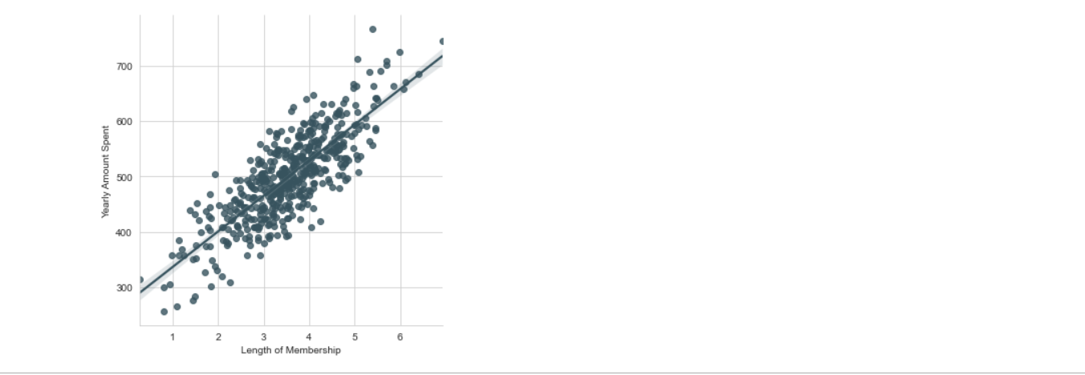

*KNN ALGORITHM PREDICTION SCORE*

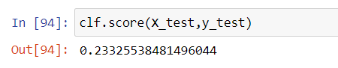

LINEAR REGRESSION PREDICTION SCORE

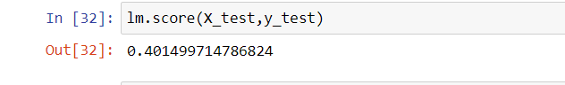

*OUR APPROACH :*

***START***

***ENTER THE DATA SET TO BE EXAMINED IN CODE***

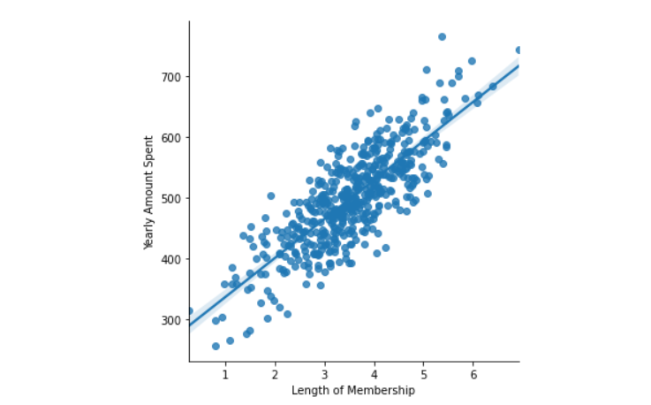

KNN PREDICTION LINE

M.L ALGO.

D.L ALGO.

FROM ANALYSIS WE CAN FIND OUT WHICH ALGORITHM IS BEST FOR GIVEN DATA SET

END

#### **Performance of different algorithms with change in amount of data.jpg**

#### **FUTURE WORK AND CONCLUSION:**

#### We will try to make our algorithm code more precise and has less complexity. We will improve the error and prediction within the code so that it will take less time.**We use linear regression within machine learning on E-commerce data set and found that scores comes up to 98.55% and in KNN we found it comes up to 89.09%and if we use another algorithm like alexnet , googlenet, SVM then prediction will be more precise but we need large data set for this .** We will use python as a coding language so we can use ML and Deep learning. It is also fast and easy to understand. This algorithm can solve our basic day – to – day problems so that everybody can easily get profit of that and we can teach ongoing generation the real purpose of coding for which it is invented i.e welfare of our societyThe results show that the proposed approach can objectively classify the algorithm of ML and Deep learning on the basis of accuracy and less time complexity. By applying these algorithm we can make our life easier i.e Virtual Assistants (Smart Speaker**),** **Predictions whileCommuting(**Traffic Predictions, Online Transportation Networks), **Social Media Services,** People You May Know, Face Recognition, **Email Spam and Malware Filtering ,** **Online Customer Support ,** **Search Engine Result Refining ,** **Product Recommendations ,** **Online Fraud Detection**

**Reference :**

1. 1674-9871/© 2019 China University of Geosciences (Beijing) and Peking University. Production and hosting by Elsevier B.V. This is an open access article under the CC BY-NC-ND license (http://creativecommons.org/licenses/by-nc-nd/4.0/)
2. Publication:[ACM SIGCOMM Computer Communication Review](https://dl.acm.org/newsletter/sigcomm-ccr)October 2006 <https://doi.org/10.1145/1163593.1163596>
3. **Published:November 20,2018**[**https://doi.org/10.1371/journal.pmed.1002686**](https://doi.org/10.1371/journal.pmed.1002686)
4. **Published in:**[**IEEE Geoscience and Remote Sensing Letters**](https://ieeexplore.ieee.org/xpl/RecentIssue.jsp?punumber=8859)**( Volume: 14,**[**Issue: 5**](https://ieeexplore.ieee.org/xpl/tocresult.jsp?isnumber=7906640)**, May 2017)**
5. Breiman, L., Friedman, J., Olshen, R., & Stone, C. (1994). Classification and Regression Trees. New York, NY: Chapman and Hall

13. <https://doi.org/10.1016/j.jhydrol.2020.125241>[Get rights and content](https://s100.copyright.com/AppDispatchServlet?publisherName=ELS&contentID=S0022169420307010&orderBeanReset=true)

14. Journal of Complexity in Health Sciences, Vol. 3, Issue 1, 2020, p. 62- 72. <https://doi.org/10.21595/chs.2020.21266>  
Received 23 December 2019; received in revised form 1 February 2020; accepted 10 February 2020; published 30 June 2020

*15.* Jepsen, S.M.; Harmon, T.C.; Meadows, M.W.; Hunsaker, C.T. 2016. Hydrogeologic influence on changes in snowmelt runoff with climate warming: Numerical experiments on a mid-elevation catchment in the Sierra Nevada, USA. Journal of Hydrology. 533: 332-342.

1. Breslow, L. A. & Aha, D. W. (1997). Simplifying decision trees: A survey. *Knowledge Engineering Review*, *12*,

1. [An Efficient Classification of Tuberous Sclerosis Disease Using Nature Inspired PSO and ACO Based Optimized Neural Network](https://link.springer.com/chapter/10.1007/978-3-030-33820-6_1)
2. *Shamim Ripon, Md. Gola*m Sarowar, Fahima Qasim, Shamse Tasnim Cynthia

[Facial Age Estimation Using Compact Facial Features](https://link.springer.com/chapter/10.1007/978-3-030-59006-2_1)

1. Joseph Damilola Akinyemi, Olufade Falade Williams Onifade
2. Published under licence by IOP Publishing Ltd  
   [Journal of Physics: Conference Series](https://iopscience.iop.org/journal/1742-6596), [Volume 1453](https://iopscience.iop.org/volume/1742-6596/1453), [2019 2nd International Conference on Computer Information Science and Artificial Intelligence (CISAI 2019), 25-27 October 2019, Xi'an, China](https://iopscience.iop.org/issue/1742-6596/1453/1)
3. Published online: 07 May 2020 <https://doi.org/10.1080/08839514.2020.1730630>